Session 7:
Creating a Healthy Discipleship Environment
(The ‘How’ of Discipleship 1)
 | Head Heart Hands
 | PRACTICAL |  | “Christians grow when we have practical and realistic plans and practices to prioritise our spiritual growth”.
 | ENVISIONED |  | “Christians grow when we have a clear vision of God, ourselves, and everyday faith that has spiritual growth as an obvious and desirable consequence”.
 | ACTIVATED |  | “Christians grow when they put into practice new ideas and teaching they gain, often from the invitation of others”

‘The issue is not whether church congregations will form people… but what they will form in people’ (Roger Walton). So how do we want our churches/small groups to be healthy environments for growing disciples? What does that look like in practice?

Key Bible Passages
- Colossians 3.12-17
- Philippians 2.1-13

Part 1: Safety, Support and Challenge
To foster an environment in which we can grow as disciples, and help others grow, we need meaningful relationships which offer three things:  - A commitment to a safe environment as the bedrock of everything else;  - Plenty of support, example and encouragement… along with…  - The invitation and challenge to change and grow into our identity and calling in Christ - both individually and as a small group or church. |  | Space for your notes

Discuss:
- Do ‘safety, support and challenge’ make sense as building blocks for a healthy discipleship environment?

- Was there anything from the video/session material you didn’t understand, or wanted to question or challenge?

- What can happen if we don’t intentionally seek to create a healthy discipleship environment?

Discipleship Questions:
You can take these questions away and use them in a one-to-one, prayer triplet, small group or other setting.
- Which interaction with another Christian has most encouraged me in my life recently?

- Which interaction with another Christian has most challenged me in my life recently?

- Who am I encouraging in discipleship recently?

- Where could I offer (appropriate and gentle) challenge to someone else to help them in their discipleship currently?

Space for your notes…

Discipleship Tool/Practice: Support/Challenge Matrix

You may have seen the relationship between ‘support’ and ‘challenge’ represented on a diagram like this one. It has been used in various organisations, and there are various versions available online. This version has been adapted specifically for this resource.
First, look at this blank grid. Notice how there are four possible types of environment, depending on whether the culture of support is ‘high’ or ‘low’, and whether there is a culture of ‘high’ or ‘low’ challenge.
Reflect/discuss: what would each of these look and feel like in a church or a small group?
- What sort of vision of discipleship would each offer?
- What would relationships between leaders and members be like?
- What is their likely approach to discipleship and mission?

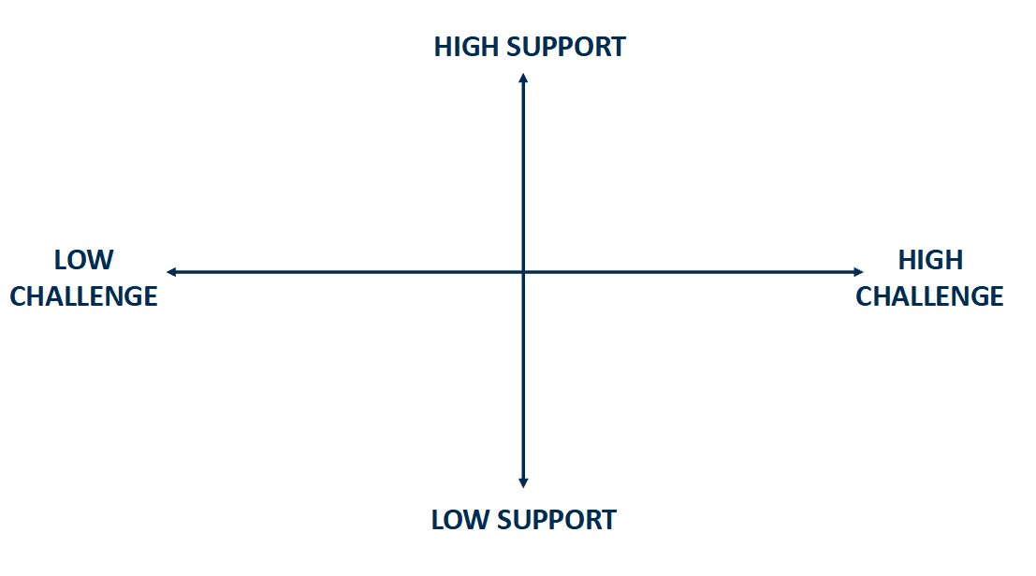
Now look at another version of the same grid on the next page, which offers a possible description of each of the four support/challenge environments.

Reflect/discuss:
- How far do you agree with the descriptions offered?
- Do you have any experience of any of these support/challenge environments in different churches or other groups you have belonged to? What were the effects of these?
- Discipleship-wise, what does healthy challenge look like? And unhealthy challenge?
- Could you use or adapt this tool in your group or church? How?

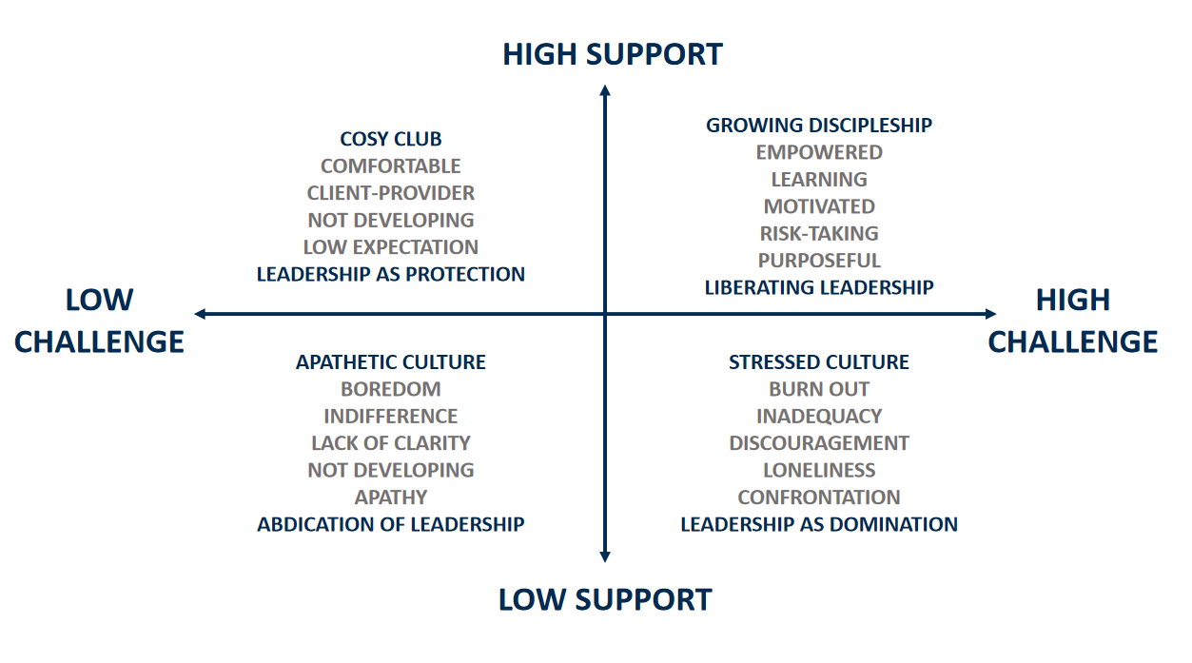
Very important: This diagram is offered as a tool to reflect on the current culture of your group or church, and to invite you to consider any changes you may want to make to your common life. At this level, the support/challenge matrix has proved a useful reflection tool in many different types of group and organisation.
HEALTH WARNING: There is a school of thought which believes that the way to tackle ‘low challenge’ cultures is to create ‘high challenge, low support’ situations and then to gradually reintroduce a greater measure of support. HOWEVER, creating a cycle of pressure or challenge situations and then seeking to offer relief from those situations is abusive and should be avoided.
As Discipleship enablers we may invite others to step out in new ways, and in an atmosphere of safety and mutual trust we may freely choose to ask and be asked challenging questions. But we should not generate stressful, discouraging, confrontational situations ourselves; we should support and encourage people through the challenging situations we/they are experiencing.
Setting up a constant cycle of support and challenge ultimately doesn’t actually work either: it just leaves people feeling insecure, anxious and exhausted. And it’s a long way from the vision of freedom, ‘fullness of life’ and an ‘easy yoke’ which Jesus offered. So use the support/challenge tool, but do so with real care!

Part 2 - Creating a Culture of Discipleship in a Local Church
What a church leader (and others) can do Space for your notes…
- Get your posture right: everyone’s a learner; we all help each other grow

- Ask good questions: what is our plan for discipleship? Is it working?

- Agree to experiment – it’s OK to discover the answers together.

- Pray for deeper discipleship; connect worship to discipleship

- Offer a rich and rounded vision of discipleship – keep sharing it.

- It’s often best to start with people’s existing gifts and passions (but don’t neglect the gaps and stumbling blocks)

- Grow people; not programmes. Be relational, adaptable and interruptible.

- Offer (real, honest) models and stories of discipleship.

- Take a whole church approach (not just small group courses). Worship + preaching helpful but insufficient by themselves?

- Line up systems, structures and practical decisions with your discipleship vision – time, money, resources.

- Develop a pathway of opportunities throughout the year for people to go deeper.

- Help people learn practical skills in discipleship, as well as catching the vision.

- Take it step by step – make ‘one degree shifts’ in developing discipleship opportunities.

- Look for those who are hungry/are bearing fruit. Encourage and develop these, but don’t neglect everyone else in the process.

- Keep persevering – discipleship is a lifetime’s work/journey.

What a church member (and leaders!) can do Space for your notes…
- Pray for a deepening of discipleship in your group/church; ask for wisdom about how/where to start.

- Engage constructively with your church leader – share your hopes rather than complaints.

- Be the change we hope to see in our church’s life.

- Ask to gather those who are keen to go deeper, and journey together.

- Look for opportunities beyond your church to take part in things that resource and enrich you. Share what you’ve experienced with your church.

- Share and celebrate any ‘good fruit’ from your own group with the wider church. Talk about what’s helped you grow.

- Find fellow travellers for prayer, support and encouragement – outside your church if need be.

- Keep humble – don’t overlook the signs of growth in what your church is already doing.

Discipleship Questions:

You could use these questions to resource a discussion in you small group, PCC or church.
- What does our church’s/group’s discipleship ‘soil’ look like at the moment? What are we reaping from this soil at the moment? How might we enrich that soil?

Or to phrase this in a different way…

- What would a healthy discipleship environment look like in practice in our church/group?

- What are we already doing well in terms of discipleship? How can we encourage more of this?

- Where might there be room to grow and develop further?

Roger Walton, Disciples Together: Discipleship, Formation and Small Groups (SCM Press, London, 2014), p.31.

