Easter Dessert Activity 2
Topic: Easter |  |  | Faith: Christianity
Menu |  |  |  | How Long
Starter

Main

Dessert | Easter Eggs |  |  | 25 Minutes
Total Time
25 mins
Activity Description
Easter eggs are a traditional part of Easter. Eggs symbolise life and resurrection, especially in Christian tradition. This activity gives young people the opportunity to decorate a wooden Easter egg and give it to a friend or family member as an Easter gift.
Activity Explanation
Explain to the young people that Easter eggs are used as a symbol of new life and resurrection. Explain that Christians link this to the death ad resurrection of Jesus Christ and the egg symbolises his resurrection from the tomb.

For this activity, you will need to purchase some wooden two-part eggs. These are readily available from craft websites such as Baker Ross for a modest price. They are excellent quality and can be painted on with acrylic paints. Invite the young people to take one, decorate it and give it to a friend or family member.
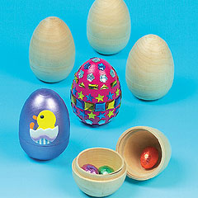

Resources
Wooden egg kit – available from baker ross website (£4 for four eggs or £14.88 for 16).
Mini chocolate eggs - to place inside the wooden egg.
Learning Objectives
Young people will know the symbolism of eggs within Easter and how that links to the Easter story of Jesus.
Suggested Levels Level 1 (Foundation)

Vocational Areas Trialled
Foundation Learning.
Tracking
Learning Style |  | Visual and Auditory.
Spiritual/Moral/Social/Cultural |  | The Easter story is primarily a Christian festival. Students will have the opportunity to learn more about why Christians celebrate this festival, including the significance of eggs in Easter culture.
Every Child Matters |  | Enjoy and Achieve – young people will create a gift for a friend or member of family.
Equality and Diversity |  | Tutors may need to ensure there is additional support for students who struggle with motor / hand functions.
Health and Safety |  | N/A
Risk Assessment |  | Low. Classroom, group activity.

